

**Socialendar**

**Project Design**

|  |  |
| --- | --- |
| Course/CRN | Software Engineering / 13329 |
| Date | 26/11/2017 |
| Team Members | Yunus Güngör  Sinan Kartal  Mustafa Sağlam  M.Enes Kayılıoğlu  Recep Can Babaoğlu |

# 1.Introduction

With the rise of social events, people are getting more sociable. They meet each other at social events and organize a plan together. The Socialendar application bring people together who will join same organizations efficiently, easily and precisely.

Socialendar project team has introduced the project step by step each report.

The purpose of this report is introducing design specifications clearly. The report consists of three main part: Data Model, Early Software Model, User Interface Model which are based on past reports.

# 2.Data Model

## 2.1 General Data Model

User, Calendar and Chatroom components in Conceptual model are explained in detail in general data model.

## 2.2 Important Data Considerations

This application includes two different data types for storing events. One type formed by operating system (iOS or Android) and another type acts as a wrapper with extra information. Device event data type provided by the operating system, and it is merged before sending to the database with calendar info which is provided by operating system. Information about device calendar which has device event attached to the device event. This implementation reduces development time and run time significantly when synchronizing events.

All data objects will be implemented as a JSON object since this application uses Firebase Database. Firebase Database is a NoSQL, JSON based, real time database. Chatroom implementation will use Firebase Database’s real time update functionalities to provide instant messaging.

User data objects does not contain a password since, all authentication handled by Firebase Authentication api. This api provides fast, easy, integrated with Facebook and Google, secure authentication. This authentication creates security in app and also creates security in accessing to database. If a device not authorized, it will not able to access to the database.

## 2.3 Data Flow Diagrams

### 2.3.1 Level 0 Data Flow Diagram

### 2.3.2 Level 1 Data Flow Diagram

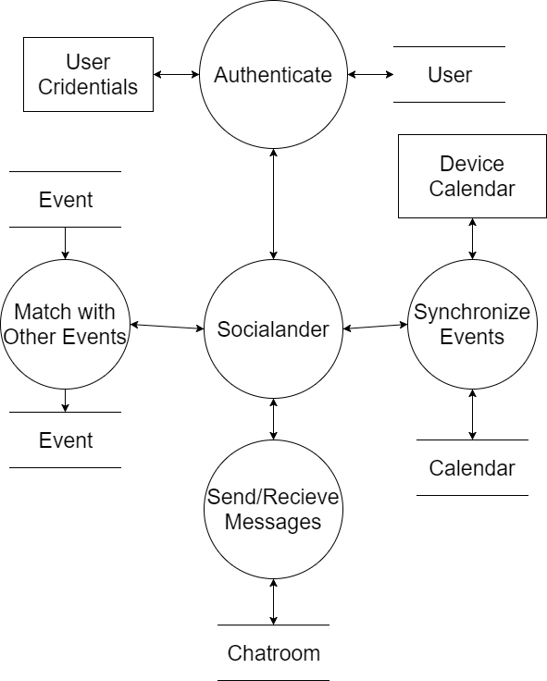

### 2.3.3 Level 2 Data Flow Diagram

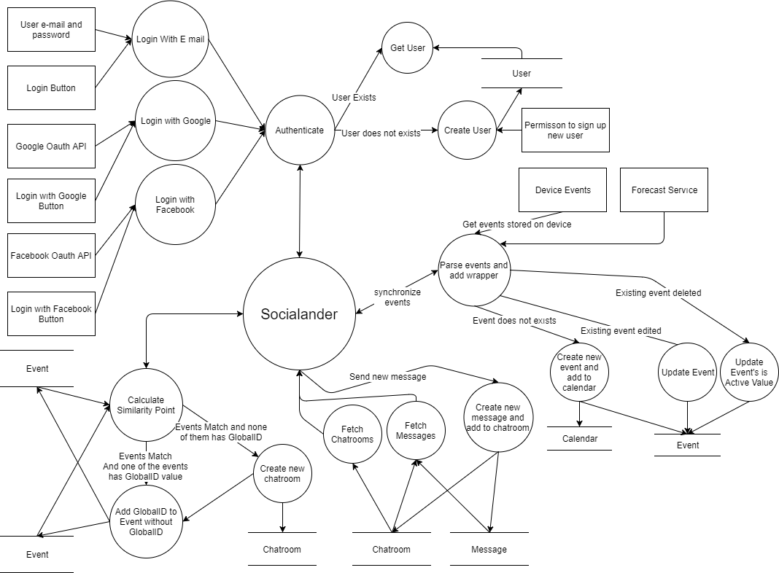2.3.4 Level 3 Data Flow Diagram

3. Software Model

## 3.1 System Architecture

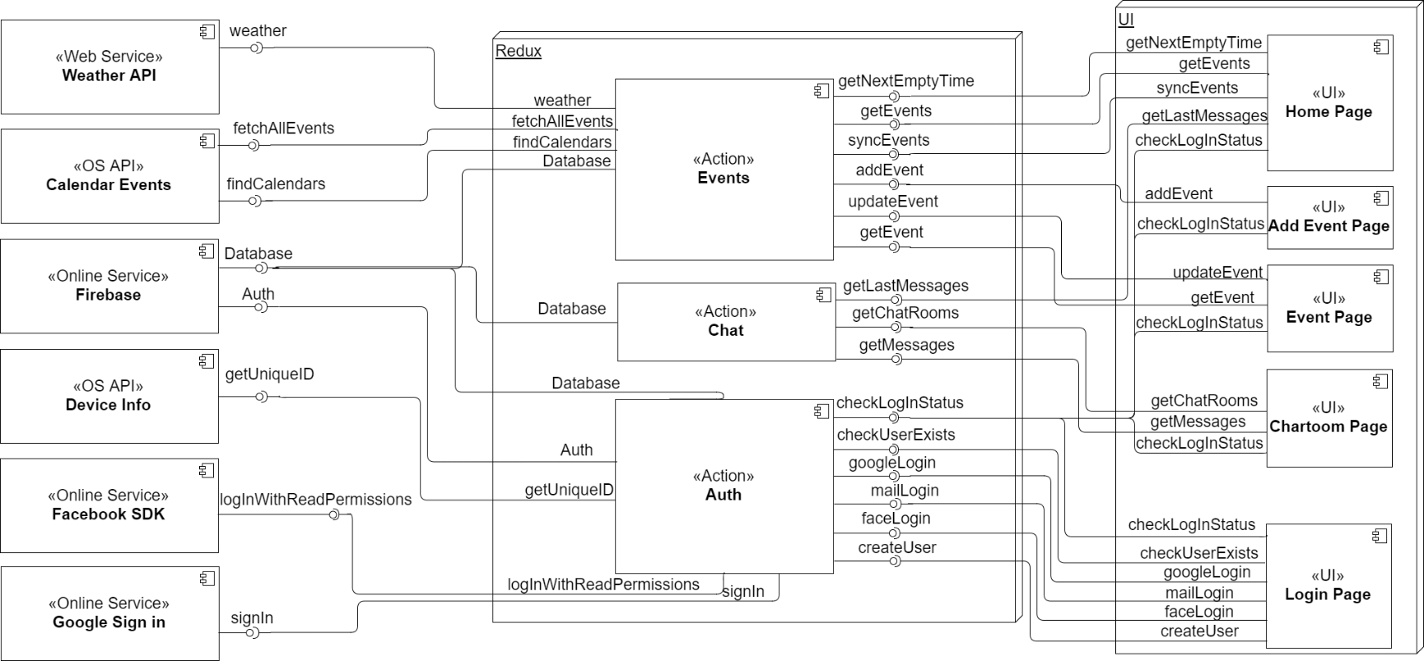 3.2 Component (Package) Diagram

Redux is react native framework that provides an application wide state for storing data and modifying that data. This approach can be identified as application context. All the functions in redux accessible to UI components, and redux state of the application is useful for getting context in components. All data flows and essential functions that communicates with other components happens in redux framework. Those type of functions called redux actions and those type of data called redux reducers.

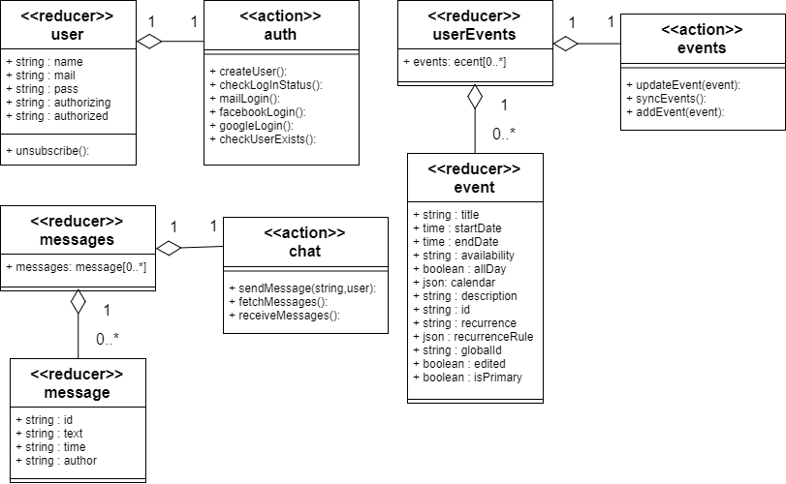 3.3 Class Diagrams

Weather API, Calendar Events, Firebase, Device Info, Facebook SDK, Google Sign In components is outsourced therefore out of scope for class diagrams. User interface interactions and user interface structure modelled in sequence diagram section of this document and also out of scope for class diagrams.

Also keep in mind that, application uses redux which does not offer any structure for access levels. Also data and functions in redux has separation as redux actions and redux reducers which is explained in component diagram part.

3.4 Sequence Diagram.

3.4.1 Login Page

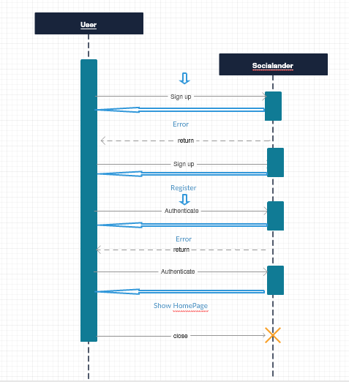

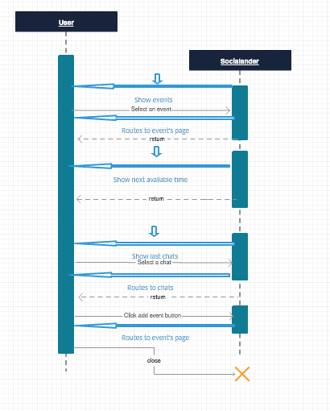 3.4.2 Home Page

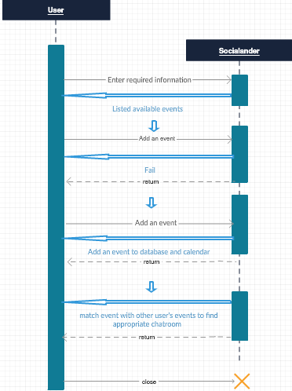 3.4.3 Add Event Page

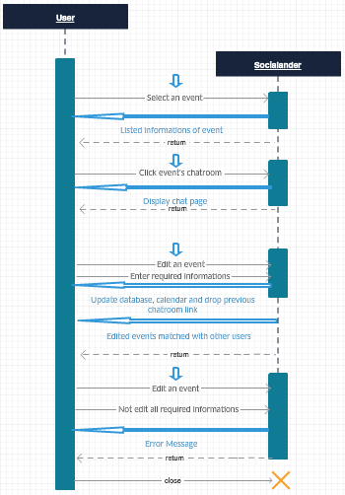3.4.4 Event Page

3.4.4 Chatroom Page

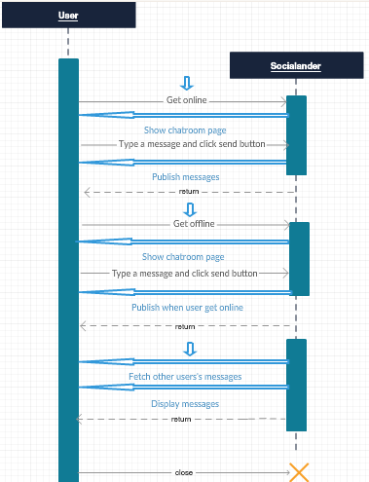

# 4.User Interface Model

* Log in page is used to access user data for authentication
* User name and password is first option for login, username can be also mail address
* 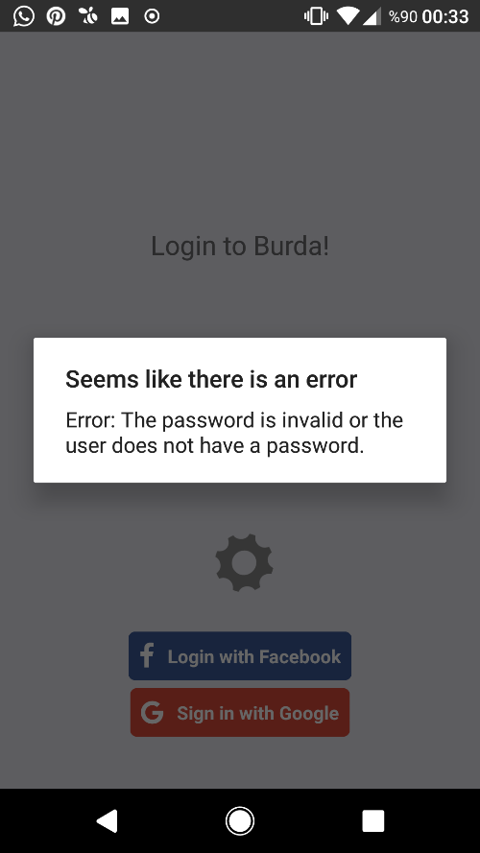Also, Facebook or Google account is another option

-Failed login is send an error message to screen

-After clicking anywhere expect message screen user will have a chance rewrite username and password

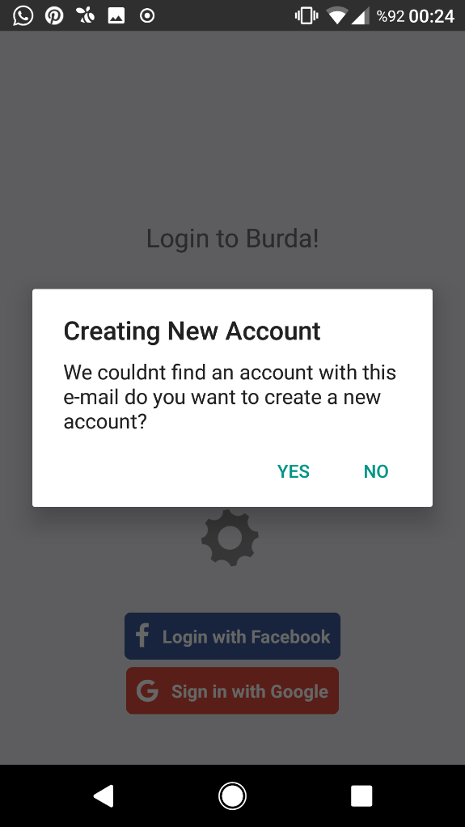

-User does not exists, display an error message and ask for permission

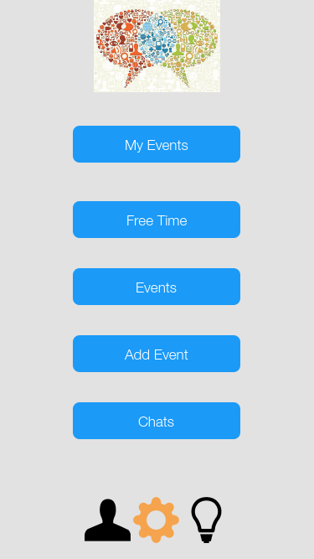-After getting permission create new user

-Home Page to use all features of application

-User can see own events and see next free time to organize schedule

-Also user can be redirected to add event page for creating a new event

-Chats section is showing recent messages and redirects to chats page

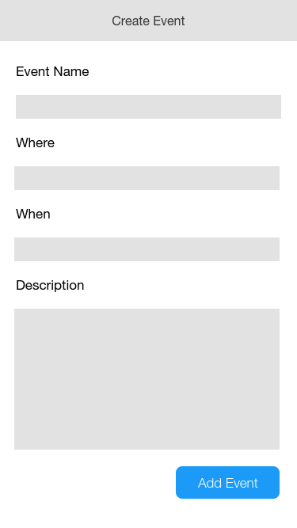

-User can use add event screen to create new event

-Event name, location and time has to be written to find clear match result.

-Also, to understand the event, description has to filled with necessary details.

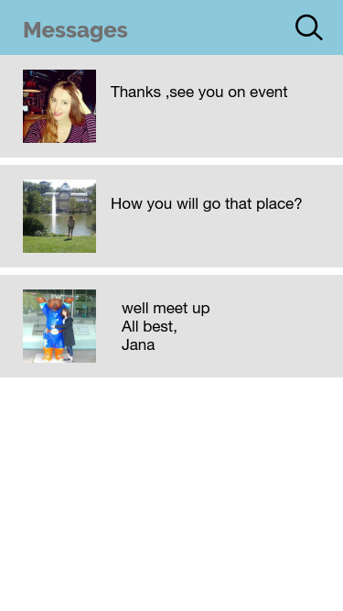

-Messages are available to see in chats room screen

-This part is to help communication between people who are attending to the same event